EXERCISE 1
1. Write the complete SQL statement for creating a new database called addressbook.
CREATE DATABASE ADDRESSBOOK;

2. Which statement is used to list the information about a table? How do you use this statement?
The statement is: DESCRIBE table_name;
Use employee_data for table_name.
DESCRIBE employee_data;
This statement will display the table structure for employee_data, including the column name or fields name, data types, and other properties
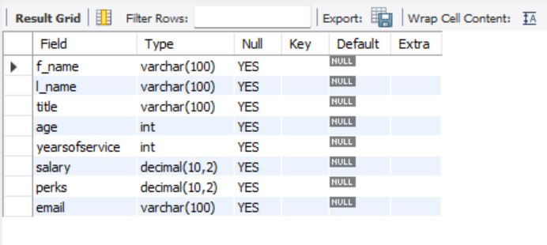

3. How would you list all the databases available on the system?
SHOW DATABASES;
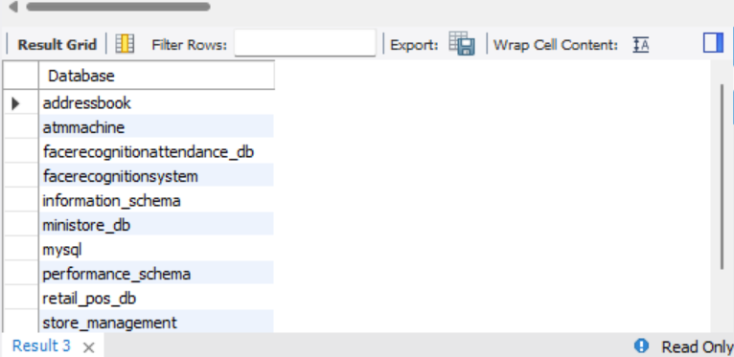

4. Write the statement for inserting the following data in employee_data table
First name: Rudolf
Last name: Reindeer
Title: Business Analyst
Age: 34
Years service: 2
Salary: 95000
Perks: 17000
Email: rudolf@bugnet.com
INSERT INTO employee_data (f_name, l_name, title, age, yearsofservice, salary, perks, email) VALUES ('Rudolf', 'Reindeer', 'Business Analyst', 34, 2, 95000, 17000, 'rudolf@bugnet.com');

5. Give two forms of the SELECT statement that will list all the data in employee_data table.
SELECT * FROM employee_data;
SELECT f_name, l_name, title, age, yearsofservice, salary, perks, email FROM employee_data;
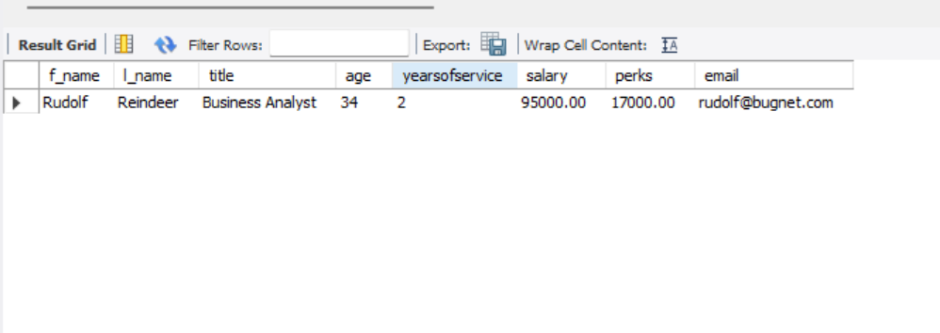

6. What will select f_name, email FROM employee_data; display?
The first name and email will display from table employee_data.
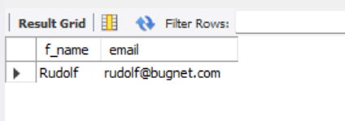

7. Write the statement for listing data from salary, perks, and yos columns of employee_data table.
SELECT salary, perks, yearsofservice FROM employee_data;
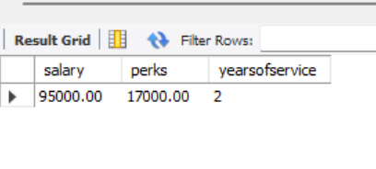

8. How can you find the number of rows in a table using the SELECT statement?
SELECT COUNT(*) FROM employee_data;
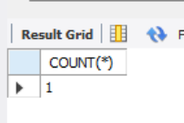

9. What will select salary, l_name FROM employee_data; display?
The salary and last name will display from table employee_data.
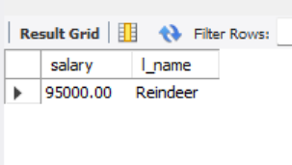

CREATE DATABASE ADDRESSBOOK;
USE ADDRESSBOOK;
CREATE TABLE employee_data (
f_name VARCHAR(100),
l_name VARCHAR(100),
title VARCHAR(100),
age INT,
yearsofservice INT,
salary DECIMAL(10,2),
perks DECIMAL(10,2),
email VARCHAR(100)
);
DESCRIBE employee_data;
SHOW DATABASES;
INSERT INTO employee_data (f_name, l_name, title, age, yearsofservice, salary, perks, email)
VALUES
('Rudolf', 'Reindeer', 'Business Analyst', 34, 2, 95000, 17000, 'rudolf@bugnet.com');
SELECT * FROM employee_data;
SELECT f_name, l_name, title, age, yearsofservice, salary, perks, email FROM employee_data;
SELECT f_name, email FROM employee_data;
SELECT salary, perks, yearsofservice FROM employee_data;
SELECT COUNT(*) FROM employee_data;
SELECT salary, l_name FROM employee_data;

